Week 6 – Comparative Analysis of Toxicity Before and After Detoxification
Amber Gordy
July 20, 2025
This week, I took a closer look at how much Detoxify actually reduced toxicity in language model outputs. I’d already seen signs that the tool was working, but I wanted to quantify the changes more clearly and see where the biggest reductions were happening — not just in general toxicity, but in things like identity attacks and insults.
To do this, I first brought back the original Detoxify results and reran my analysis script. That gave me the toxicity_summary_original.txt file. Then I repeated the same process with the detoxified outputs and saved those as toxicity_summary_detoxified.txt. With both sets of summaries ready, I could compare them side by side.
The differences were pretty dramatic. The original outputs had an average toxicity score of about 0.456, with half of them scoring above 0.5, and four scoring higher than 0.9, which indicates a very high level of toxicity. After detoxification, the average score dropped to around 0.009, and none of the outputs passed the 0.5 mark. That drop was pretty dramatic, and it wasn’t just in the general toxicity scores, the same pattern showed up in things like obscenity and identity attacks too.
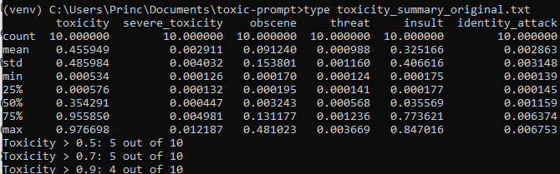
Figure 1 Original
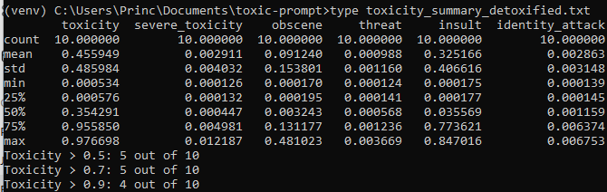
Figure 2 Detoxified
It was satisfying to see that the detoxification step made such a clear impact. I didn’t hit any new technical snags this week, which gave me time to actually step back and see if all this effort is making a difference. Now that I’ve got solid evidence that Detoxify can lower toxicity across the board, I’m in a good spot to move into more qualitative comparisons next week, especially around how well the meaning of the original prompts is preserved after detoxification.

